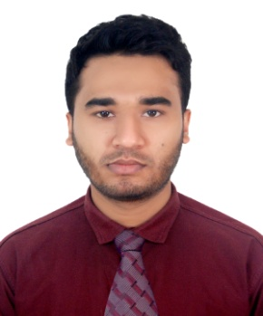

**RESUME OF**

**MD. ZIYET KARIM**

Hillview R/A, Panchlaish, Chittagong.

Contact No. : +8801829382481, E-mail: ziyet666@gmail.com

|  |  |  |  |
| --- | --- | --- | --- |
| Career objective | Throughout my education career and work experiences, I tried to build myself as an overall qualified person. I am ready to take any responsibility and get focused on it with full dedication. | | |
| Current Location | Bangladesh | | |
| Height | 170 cm | Weight | 70 kg |
| Nationality | Bangladesh | | |
| Work Experiences | 1. Company Name: Absar Ahmed & Brother’s Filling Station **Designation : Cashier (Sales Department)**  Joining Date: 01 January 2015 , Ending Date : 15 March 2017  **Key Responsibilities** :   * Preparing and Managing various computer generated documents like buyer form, Delivery challan etc. * Maintaining bank deposit slip/Money receipt/other financial documents and forward to Head. * Properly preserve various documents and keep the records.   2. Company Name: Study Care Coaching Centre.  Designation : Compute Operator (Typing operator)  Joining Date : 01 April 2017, Ending Date : 10 February 2019.  **Key Responsibilities** :   * Copy typing involves working from hand written, printed or typed documents. * Audio typing requires speedy typing as listen to a dictation from people. * Shorthand typing. Need to take notes at conversation pace which can then be typed up properly later.   3. Company Name: Noor Crockery  Designation : Compute Operator (Typing operator)  Joining Date : 7 April 2019 , Ending Date : 3 January 2020  **Key Responsibilities** :   * Copy typing involves working from hand written, printed or typed documents and Daily bill typing etc. * Cash Memo etc. | | |
| Educational Qualification | **Secondary School Certificate (S.S.C)**  Institution : Technical Training Center  Group : Mechanical Drafting with CAD  Result : 4.27 ( out of 5.00 )  Passing Year : 2011  Board : Bangladesh Technical Education Board (BTEB).  **Diploma in Engineering**  Institution : Shyamoli Ideal Polytechnic Institute  Group : Automobile  Result : 2.87 ( out of 4.00 )  Passing Year : 2016  Board : Bangladesh Technical Education Board (BTEB). | | |
| Languages skill | Good command over reading, writing, listening and speaking English. | | |
| Computer Skills | MS Word, Ms Excel, Ms Access, Ms PowerPoint & Photoshop etc. | | |
| Typing Speed | English -36, Bagla-38 | | |

|  |  |
| --- | --- |
| Personal Information | Name: Md. Ziyet Karim  Father’s Name: Md. Kamal Pasa  Mother’s Name: Bibi Jainub  Date of Birth: 5th December, 1994  Marital status: Single  Gender: Male  Religion: Islam  Nationality : Bangladeshi. |
| Present Address : | Mokkha tower,5 no road/A block Hillview Housing Society, Panchlaish, Chittagong. |
| Permanent Address: | Village- Shahnagar, Post Office- Shahnagar,  13 No. Lelung Union, Police Station- Fatickchari,  District- Chittagong, Country- Bangladesh. |

………………

**Signature**